Build a simple social network program.

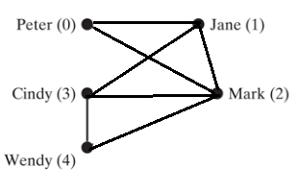

You are given the above relationship diagram.

1. Import this diagram into a graph class as shown in the code example.

2. Prompt the user to add new user.

3. Prompt the user to add friends.

4. After adding friends, display the friends for each users.

Ex:

**Please add new user:**

Enter: Tom

Please select who you want to add from this list, add one friend at a time, enter -1 to exit.

0: Peter

1: Jane

2: Mark

3. Cindy

4. Wendy

Enter: 1

You have friended Jane.

Please select who you want to add from this list, add one friend at a time, enter -1 to exit.

Enter: 2

You have friended mark

Please select who you want to add from this list, add one friend at a time, enter -1 to exit.

Enter: -1

The friend list for all users are:

Peter (0): (0, 1), (0, 2)

Jane (1): (1, 0), (1, 2), (1, 3)

Mark (2): ……

Cindy (3):……

Wendy (4):…..

Tom (5): (5,1), (5, 2)

Also display the friend list as actual names:

Ex:

Friends of Peter: Jane, Mark

Friends of Jane: Peter, Mark, Cindy

……

